Worksheet 7.4

Global warming
Answers
The two graphs below show information about the atmosphere during the twentieth century.

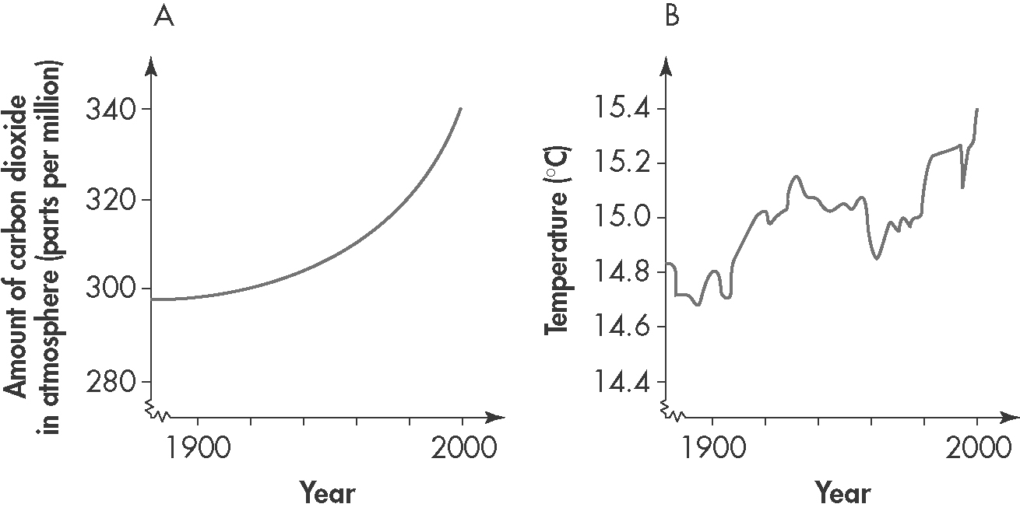
1. The increase in carbon dioxide levels in the atmosphere over the 100 years of the twentieth century as a percentage is approximately:
A. 14%
B. 40%
C. 297%
D. 337%
2. The percentage increase in atmospheric temperatures over the 100 years of the twentieth century is approximately:
A. 4.7%
B. 14.8%
C. 15.4%
D. 2.35%
3. (a) Identify the major source of carbon dioxide in the atmosphere.
Burning of fossil fuels

(b) Explain the connection between carbon dioxide and global warming.
Heat radiation from the Earth is absorbed by gases such as carbon dioxide and methane in the atmosphere. This leads to a heating of the atmosphere as the radiation cannot escape back into space. The process is enhanced if more of these gases are present in the atmosphere.

(c) Outline possible strategies for reducing the amount of carbon dioxide that enters the atmosphere.
Carbon sequestration (i.e. capturing and burying the carbon dioxide deep underground); or increase the use of other energy sources such as solar, wind and nuclear energy.

Worksheet 7.4

Page 2

Greenhouse effect
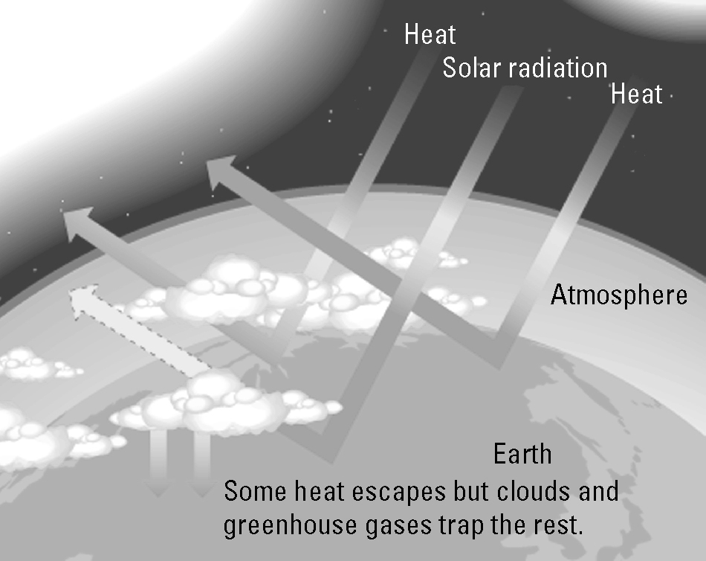 | 4. (a) Use the graphic on the right to explain how the natural greenhouse effect keeps our planet warm.  Radiation from the sun is partly absorbed and partly reflected back into space. Water vapour (in clouds or the air) as well as carbon dioxide and methane are molecules in the atmosphere that absorb radiation and warm our planet.
(b) Identify the cause of the enhanced greenhouse effect.
The enhanced greenhouse effect is due to human activities where additional carbon dioxide and methane are released into the atmosphere via the combustion of fossil fuels.

(c) Explain why the enhanced greenhouse effect is of major concern.
These additional amounts of greenhouse gas produce greater warming than normal.

Carbon dioxide concentrations
5. The following table provides atmospheric carbon dioxide data over recent times.
(a) Plot a line graph of this data and draw the line of best fit.
Year | CO₂ (ppm) | 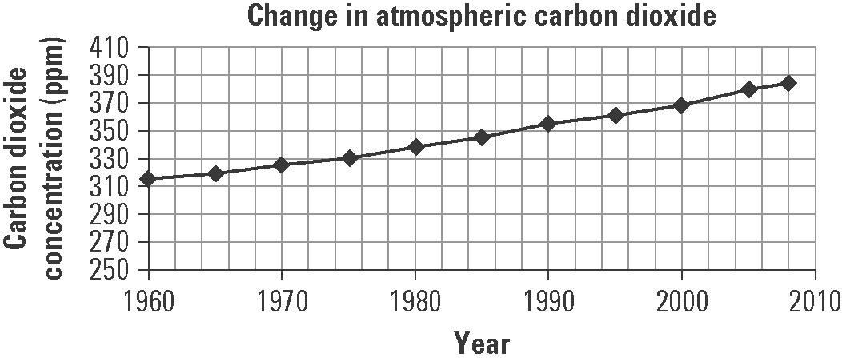
1960 | 317
1965 | 321
1970 | 327
1975 | 332
1980 | 340
1985 | 347
1990 | 356
1995 | 362
2000 | 370
2005 | 381
2008 | 386
(b) Global average temperatures have risen during this period. Is this evidence sufficient to state that global warming is caused by increases in carbon dioxide levels? Explain.
No the evidence is not sufficient on its own to make these conclusions. More data will need to be collected to confirm or refute the hypothesis.

